# **Name: Abdurrahman Qureshi**

# **Roll No: 210451**

Practical No: 19

**1) Write a Program to update row of student table from MSBTE database using Mysql 5.5 a database server.**

import java.sql.*;  
public class Main {  
 public static void main(String args[]) {  
 try {  
 Class.forName("com.mysql.cj.jdbc.Driver");  
 Connection con = DriverManager.getConnection("jdbc:mysql://localhost:3306/MSBTE", "root", "qazi");  
 Statement st = con.createStatement();  
 st.executeUpdate("update student set name='Dawg' where id=3");  
 System.out.println("Record Updated.");  
 con.close();  
 } catch (Exception e) {  
 System.out.println(e);  
 }}}

**OUTPUT:**

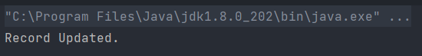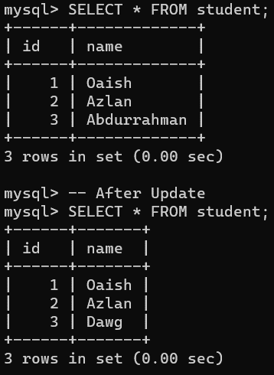

**2) Write the output of following JDBC code. Use Mysql server 5.5 as database server**

**CODE:**

import java.sql.*;  
public class Main {  
 public static void main(String args[]) {  
 try {Class.forName("com.mysql.jdbc.Driver");  
 Connection  
 con = DriverManager.getConnection("jdbc:mysql://localhost:3306/MSBTE", "root", "qazi");  
 PreparedStatement stmt = con.prepareStatement("insert into student values(?,?)");  
 stmt.setInt(1, 4);  
 stmt.setString(2, "Mohiuddin");  
 int i = stmt.executeUpdate();  
 System.out.println(i + " records inserted");  
 con.close();  
 } catch (Exception e) {  
 System.out.println(e);  
 }}}

**OUTPUT:**

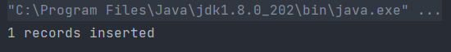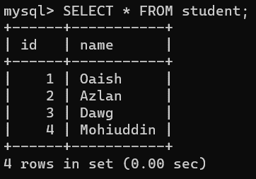

**3) Develop JDBC program to retrieve data using ResultSet**

**CODE:**

import java.sql.*;  
public class Main {  
 public static void main(String args[]) {  
 try {  
 Class.forName("com.mysql.cj.jdbc.Driver");  
 Connection  
 con = DriverManager.getConnection("jdbc:mysql://localhost:3306/MSBTE", "root", "qazi");  
 Statement stmt = con.createStatement();  
 ResultSet rs = stmt.executeQuery("select * from student");  
 System.out.println("Roll No.\tName");  
 while (rs.next()) {  
 System.out.println(rs.getInt(1) + "\t\t" + rs.getString(2));  
 }  
 con.close();  
 } catch (Exception e) {  
 System.out.println(e); }}}

**OUTPUT:**

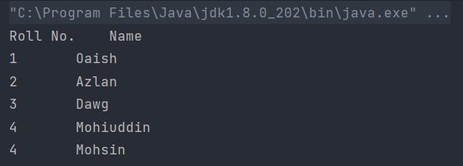

**4) Develop a program to update a record in database table**

**CODE:**

import java.sql.*;

public class Main {

public static void main(String[] args) {

try {

Class.forName("com.mysql.cj.jdbc.Driver");

Connection

con = DriverManager.getConnection("jdbc:mysql://localhost:3306/MSBTE", "root", "qazi");

Statement stmt = con.createStatement();

stmt.executeUpdate("update student set name='Hussain' where name='Mohsin'");

System.out.println("Record Updated");

con.close();

} catch (Exception e) {

System.out.println(e);}}}

**OUTPUT:**

